ROUTE DETAILS FOR THE 50K/50M KIDNEY CYCLE – 7 OCT 18
50 mile Route
The start point for the cycle is Manchester Royal Infirmary right in the heart of the city. The cycle route then heads out of Manchester avoiding the main roads and travels west alongside Whitworth Park, through Stretford and the Old Trafford sporting venues. As we turn southwards the route goes through Flixton, Carrington and onto Bowdon and the Cheshire countryside lanes. We will travel deeper into beautiful Cheshire through the villages of Astley, Mobberley and Warford staying on peaceful country lanes before passing through the historic town of Knutsford. We make our way into the National Trust picturesque Tatton Park where we will hopefully see the roaming deer! It’s then out of the park on the back roads to Dunham. We cycle back towards Manchester passing Lymm and then Stretford, again utilising the roads with less traffic before the final stint back to the MRI, home of Kidneys for Life, for a well-deserved celebratory finish!

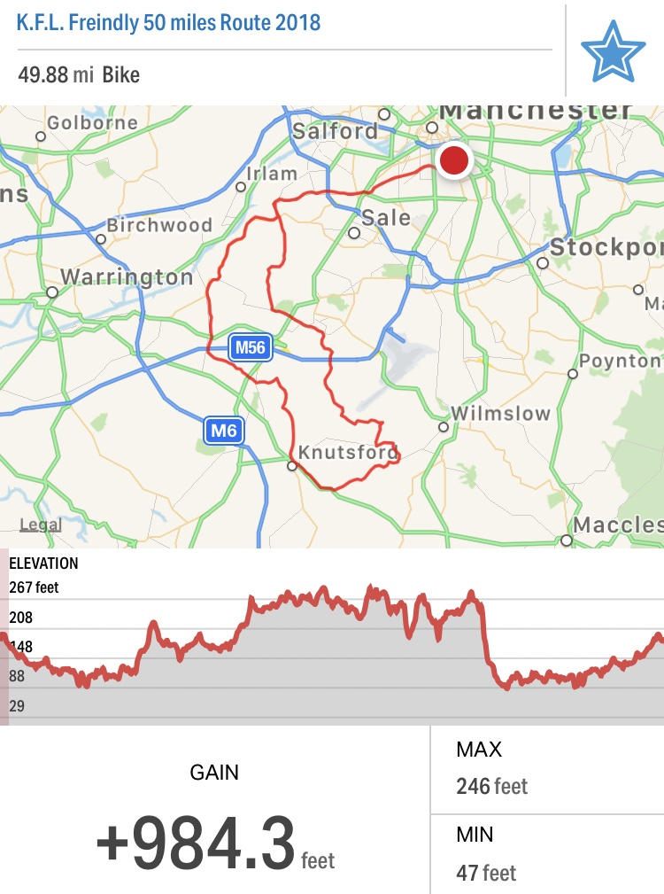

50 kilometre Route
The start point for the cycle is Manchester Royal Infirmary right in the heart of the city. The cycle route then heads out of Manchester avoiding the main roads and travels west alongside Whitworth Park, through Stretford and the Old Trafford sporting venues. We will not be using the main roads in the city and as we turn southwards the route goes through Flixton and Carrington, passing by Stretford and Urmston Meadows. From here we cycle along the Cheshire lanes and over a small picturesque bridge passing by Dunham Massey Hall, Little Bollington and into the village of Heatley. The route turns north eastwards through the back lanes to Partington and Carrington. From here we head back towards the city and into Stretford to re-join the outward journey route back to the home of Kidneys for Life, the MRI for a well-deserved celebratory finish!
