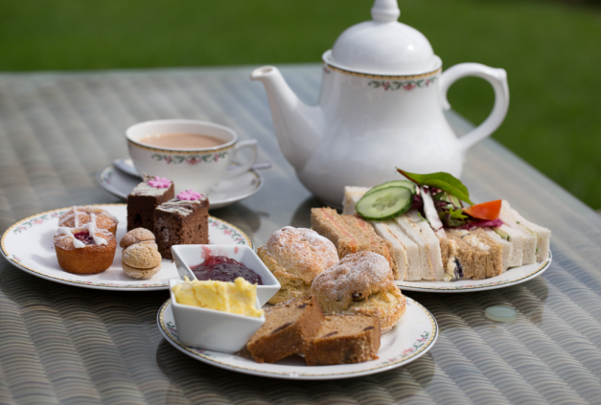
Celebrating the 50th Anniversary of the First Kidney Transplant at MRI
AFTERNOON TEA BOOKING FORM
Sunday, 25 March 2018 at 2-4pm
The Principal Hotel, Oxford Road, Manchester M60 7HA

Title |  |  | First Name
Surname
Number of Tickets at £22.50 each |  |  | Number of Tickets at £15.50 each  (children under 12) |  |  |  | Total Payable:  £
Any Special Dietary Requirements?
Do you wish to be seated with or near other guests? (We will try our best but this cannot be guaranteed)
Please advise of an address or email to send confirmation of booking
BACS | If paying by bank transfer send your payment to:  RBS, Mosley Street, Manchester M60 2BE  Account Name: Kidneys for Life Account Number: 11424879 Sort Code: 16-30-15  Please use your full name as your reference so that we can allocate payment on receipt
Cheque | Please find enclosed a cheque for the amount of £  made payable to Kidneys for Life
Please send all correspondence and cheques to:
Kidneys for Life
Renal Research Labs
MRI
Oxford Road
Manchester M13 9WL
Terms & Conditions:
Cancellations: MUST be received in writing via email to fundraiser@kidneysforlife.org or by phone to 0161 276 6671 at least 7 days prior to the event and must contain your full name and contact details. Your cancellation will be confirmed by email or post.
Please note your booking is not confirmed until payment has been received.

