ESPU Masterclass: Off-Label Treatment of Bladder
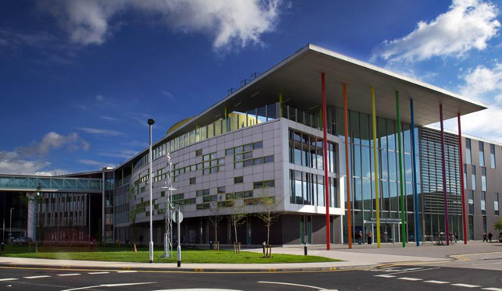
2nd June 2017
Royal Manchester Children’s Hospital,
Manchester, UK

Objectives:
- To enhance understanding of non-neurogenic bladder disorders leading to day and night time wetting
- To gain insight into off-label treatment of difficult to treat overactive bladder, giggle incontinence, nocturnal enuresis and stress incontinence
- To share knowledge on efficacy, side effect profile of off-label medication
Target Audience: All those who look after children with wetting
Paediatric Urologists / Paediatric Surgeons / Paediatric Nephrologists / Paediatricians / Urology Specialist nurses
Contact:
Ms Anju Goyal
Tel : 0044(0)1617011635
Fax: 0044(0)1617012630
Registration fee: £75 (number of participants restricted to 40)
For registration and more information visit:
www.kidneysforlife.org
Registration opens: 1st March 2017

