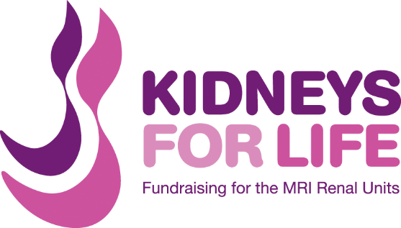
London to Paris Cycle
2-6 September 2015

Itinerary
Day 1 - London to Calais:

Your challenge starts early this morning, at Greenwich Park, where you will meet up with the rest of the riders and will register with the Event Organisers. Once you have received your starter pack for the day you will hit the road, heading East out of London and into the beautiful Kent countryside. Today's 80 mile route stays North of the South Downs, ensuring a flatter, faster route to Dover. It also takes you via some of the East of England's most stunning coastal towns and rural villages, including Whitstable and Herne Bay.

You will get the ferry from Dover to Calais that evening, staying overnight in a hotel in Calais.

Day 2 - Calais to Abbeville:

Today's 78 mile route takes you South from Calais through the rolling landscape of Northern France. This region of France is steeped in history, as it was the centre of much of the conflict in WW2, including the Battle of Agincourt. Cycling past rural farms and vineyards and through historic market towns, you will finish today in Abbeville, under the gaze of its stunning Gothic church.

Day 3 - Abbeville to Beauvais:

Continuing South out of Abbeville, the first part of today's 70 mile route follows the infamous River Somme. Today's ride is flatter than previous days, allowing you to sit back and enjoy the views; absorbing the calming nature of countryside life. We finish for the day in Beauvais, where you will be staying overnight; famous for its central market square and historic buildings.

Day 4 - Beauvais to Paris:

Today is the last day of your cycle challenge and the final push to Paris! The first part of today's 60 mile ride continues through the countryside, before reaching the outskirts of Paris itself. As you enter the city, you are greeted by views of some of Paris' famous landmarks, including but not limited to the Eiffel Tower and the Arc de Triomphe. We will meet together before the final stretch along the boulevards of Paris, so that we can arrive together under the Eiffel Tower as a group - a fitting end to a challenging journey!

We will celebrate our achievements together, this evening in Paris, and will stay overnight in the city before returning home the next day.

Day 5 - Return to London:

This morning you will have some free time to explore the city, before catching your Eurostar train back to London. Your bikes and any additional equipment will be loaded onto our vehicles and taken back to the UK for you, to be collected at your choice of either London or Manchester.

