**Phosphate Binders & Timings**

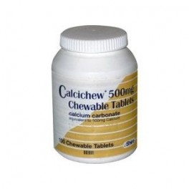

|  |  |  |
| --- | --- | --- |
| **Binder** | **When to take tablet** | **How to take tablet** |
| **Calcichew** | Before meal | Chew or suck |
| **Calcium 500** | Before meal | Chew |
| **Fosrenol Tablets** | With or immediately after meal (within 15 mins) | Chew very well |
| **Fosrenol Powder** | Immediately after meal (within 15 mins) | Mix with a small quantity of soft food (e.g. apple sauce) |
| **Osvaren** | Before meal | Swallow (can break into 2) |
| **Phosex** | During meal | Swallow |
| **Phoslo** | During meal | Swallow |
| **Renagel** | During meal | Fosrenol approved in predialysis patientsSwallow |
| **Renvela Powder** | With meals | The powder should be dispersed in 60ml of water prior to administration. The suspension should be taken within 30 minutes of preparation |

