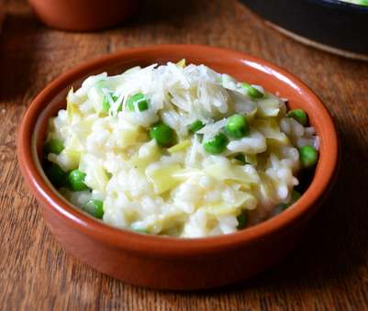
Leek and Pea Risotto

Serves 4

Ingredients
400g Arborio rice
2 leeks (finely chopped)
2 cloves of garlic (finely chopped)
1 tblspn of olive oil
Top Tip…
Other low potassium greens include; broccoli, celery, curly kale, green and runner beans and mange tout…change the ingredients to suit your taste.

100ml white wine
750ml chicken or vegetable stock (reduced salt)
Large handful of frozen peas
Small knob of butter
Large handful of parmesan cheese (grated)

Method:
1. Heat olive oil and gently fry the leek and garlic for a few minutes
2. Add the rice and stir until it has been coated with oil
3. Add the wine and cook until it has been absorbed
4. Gradually add the vegetable stock
5. Once the rice has become soft, but retains a little bite, add the peas and cook for a few minutes longer
6. Stir in the butter and parmesan and remove from the heat and serve.

