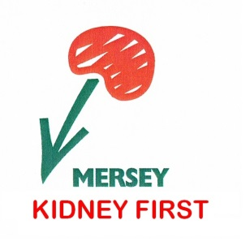
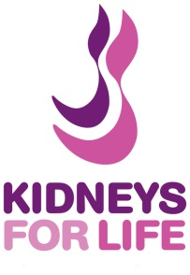
17th September 2017

Liverpool to Manchester

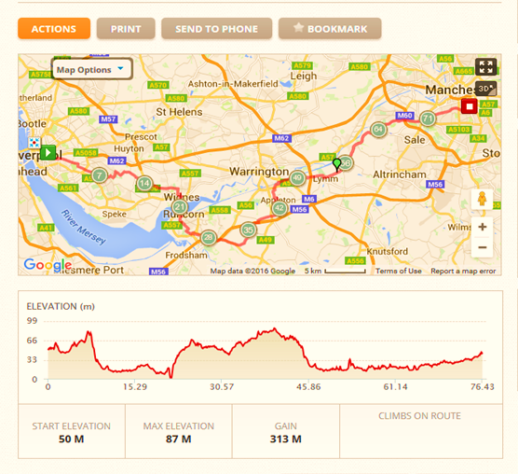

Event Details
This one day event consists of cycling 50 miles through beautiful Cheshire countryside, from the Royal Liverpool University Hospital to the Manchester Royal Infirmary, all in aid of 2 wonderful kidney charities and to raise awareness for this incredible cause. The charities raise money for research into kidney disease, transplantation, dialysis and related disease affecting the kidneys.

Itinerary

Sunday 8.00am to 8.30am – Cycle Transportation to Event Start

For participants in the Manchester area who have requested cycle transport to the start of event in Liverpool you will register with a member of our Chapeau Events crew as you hand over your cycle at Manchester Oxford Road Train Station between 8.00am and no later than 8.30am. Registration will be clearly marked at the hospital. Your cycles will be transported by Chapeau Events to the start of the event at the Royal Liverpool University Hospital, you will be re-joined with your cycle ready for the off between 9.30am-10.30am.

Sunday 9.00am to 10.30am – Registration in Liverpool

For all other participants, you will register with a member of our Chapeau events crew near to the start at the Royal Liverpool University Hospital from 9.30am until 10.30am. Registration will be clearly marked at the hospital.

Approximately 9.30am to 10.30am – Event Begins

We start the event leaving the Royal Liverpool University Hospital and head towards the charming town of Halewood, home to the Jaguar and Land Rover car manufacturers. We cycle along flat terrain to the industrial town of Widnes situated on the northern bank of the River Mersey where the estuary narrows to form the Runcorn Gap, and then continue on to Runcorn itself.

Approximately 12.15 pm to 1.30pm – Water Stop Check-in post

Our check point is at the Pickering Arms, Thelwall approximately 30 miles into the days ride. Here you will be able to replenish your drinks bottles and receive some much needed sustenance in the form of snacks etc. After checking in, you can speed off again as the route continues towards the very beautiful town of Lymm, notable for its historical buildings both listed and unlisted. Also home to a fabulous traditional sweet shop, where old favourites from long ago can still be purchased!

Approximately 2pm to 4pm – Congratulations…Event Finish!

Our final stage of the day continues as we cycle on through Carrington in Trafford, which historically used to form part of Cheshire. Lying on flat ground between the River Mersey and Manchester Ship Canal, we cruise on through Stretford, home of Manchester United football club and Lancashire Cricket Club. During much of the 19th century Stretford was an agricultural village, with its own market, known locally as Porkhampton, a reference to the large number of pigs produced for the nearby Manchester market.

We then embark onto our final stretch to our finish point at Manchester Royal Infirmary, where congratulations and celebrations will be many as we complete a great days cycling for this life saving cause.

Approximately 4pm to 5pm – Cycle Transportation back to Event Start

For participants from the Liverpool area who have requested cycle transport back to start of event in Liverpool… You will be directed by Chapeau Events crew as you hand over your cycle at Manchester Royal Infirmary. Your cycles will be transported by Chapeau Events to the start of the event at Royal Liverpool University Hospital. After which you will be re-joined with your cycle ready for home and a much deserved rest.

